

**Layoffs Analysis 2020-2022**

DATA 230 - Data Visualization for Data Analytics, Department of Applied Data Science

San Jose State University, California

Submitted By – Sahanti Samarth Zade

Enrollment Number - 016679169

Table of Contents

1. Introduction

1.1 Purpose of this document

1.2 Intended Audience

1.3 Scope

1.4 Definitions and acronyms

1.5 References

2. Abstract

3. Development process process

4.. Project plan - Time schedule

5. Reference

6. About the dataset

7. Worksheets

8. Dashboard

9. Story

**1.** **Introduction**

## Purpose of this document

The purpose of this document is to provide a detailed project description of the dashboard called layoffs analysis 2020-2022, which is designed on the dataset about the layoffs that happed in the years 2020-2022 throughout the world.

## Intended Audience

This document shall be used in the Analysis phases of the project as a guideline. Intended audiences of this project are all project stakeholders:

* project supervisor
* project leader
* team members

## Scope

This document defines the oversight of the layoffs that have happened in the year 2020 - 2022 data analysis dashboard. Here I have analyzed the layoffs dataset to get insight of the layoffs that took place in the year 2020-2022 with visualization tool called Tableau. In this analysis my duties as a Data Analyst were to understand the concentration of layoffs spread across the globe.

The overview includes objectives of the project, organization of the project team, development process that is going to be used during the project, assessment of possible risks, communication used between project stakeholders and project plan that includes time schedule and activity plan.

## Definitions and acronyms

|  |  |
| --- | --- |
| **Keyword** | **Definitions** |
| Name | The name of the project |
| Git | Version control system that will be used in this project |
| Tableau | Tools which is used to create dashboards |

## References

1. <https://public.tableau.com/app/discover>
2. <https://www.kaggle.com/datasets/swaptr/layoffs-2022>

**2. Project Abstract**

This project ‘Layoffs Analysis 2020-2022’ will provide insights on the layoffs that have taken place from the year 2020 – 2022. The Layoffs dataset provides information about the countries and cities where layoffs happened, along with the information of companies and various industries involved. i will perform analysis on the dataset to help answer below questions and more:

1. What is the number of people that were laid-off in a particular country?

2. Which city was responsible for the max number of layoffs?

3. Which industry was most affected by the layoffs?

4. What is the trend of layoffs for different industries?

5. What companies laid off of the highest number of employees?

6. What is the status of highest relief funds by the companies?

The project will provide visual representation on the trends of the layoffs for the 2 years around the globe. It will help to analyze the data more accurately to make efficient decisions.

**3. Development process**

The project will use tableau, to build a dashboard that aids in finding the story hidden in the data. Tableau is very effective software that is used to build an interactive dashboard which helps in finding the story hidden in the data and helps in the data analysis. It includes a drag-and-drop interface that is very easy to use and creative dashboards are created very quickly. The dashboard will show insight of customer segmentation based on region.

## Git

All source code and finished documentation will be uploaded to GitHub repository.

Repository URL:

**4. Project plan**

## Time schedule

|  |  |  |  |
| --- | --- | --- | --- |
| **Id** | **Milestone**  **Description** | **Finished Date** | |
|  |  | **Plan** | **Forecast** |
| 1 | Finding the data sources | 10/05/2022 | 10/05/2022 |
| 2 | Data Wrangling | 10/12/2022 | 10/12/2022 |
| 3 | Build the dashboard | 10/29/2022 | 10/29/2022 |
| 4 | Build a dashboard to present | 11/20/2022 | 11/20/2022 |
| 6 | Project Report | 11/30/2022 | 11/30/2022 |
| 7 | 15-minute live project demonstration | 12/06/2022 | 12/06/2022 |

# 

**5. References**

1. <https://public.tableau.com/app/discover>
2. <https://www.kaggle.com/datasets/swaptr/layoffs-2022>

**6. About the dataset**

Tech firms around the globe are fighting the economic slowdown. The slow consumer spending, higher interest rates by central banks and strong dollars overseas are hinting towards possible recession and tech firms have started laying employees off. This economic slowdown has made Meta recently fire 13% of its workforce, which amounts to more than 11,000 employees.

Tracking the tech layoffs reported on the following platforms:

Bloomberg

San Francisco Business Times

TechCrunch

The New York Times

**7. Layoffs Analysis**

Initially ETL (Extract Transform Load) was performed on the dataset. Following functions were performed on the dataset:

1. Read the dataset csv file into data-frame with pandas
2. Cleaned the dataset to get rid of the null values
3. Dropped the columns which were unnecessary for the analysis
4. Created updated csv file
5. Used to updated csv file in Dashboard to create visualizations

In this Dashboard one can get all the insights related to the layoffs that have happed in the year 2020-2022. The Dashboard will help us understand the below questions:

1. What is the number of people that were laid-off in a particular country?
2. Which city was responsible for the max number of layoffs?
3. Which industry was most affected by the layoffs?
4. What is the trend of layoffs for different industries?
5. What companies laid off of the highest number of employees?
6. What is the status of highest relief funds by the companies?

**8. Dashboard Visualization**

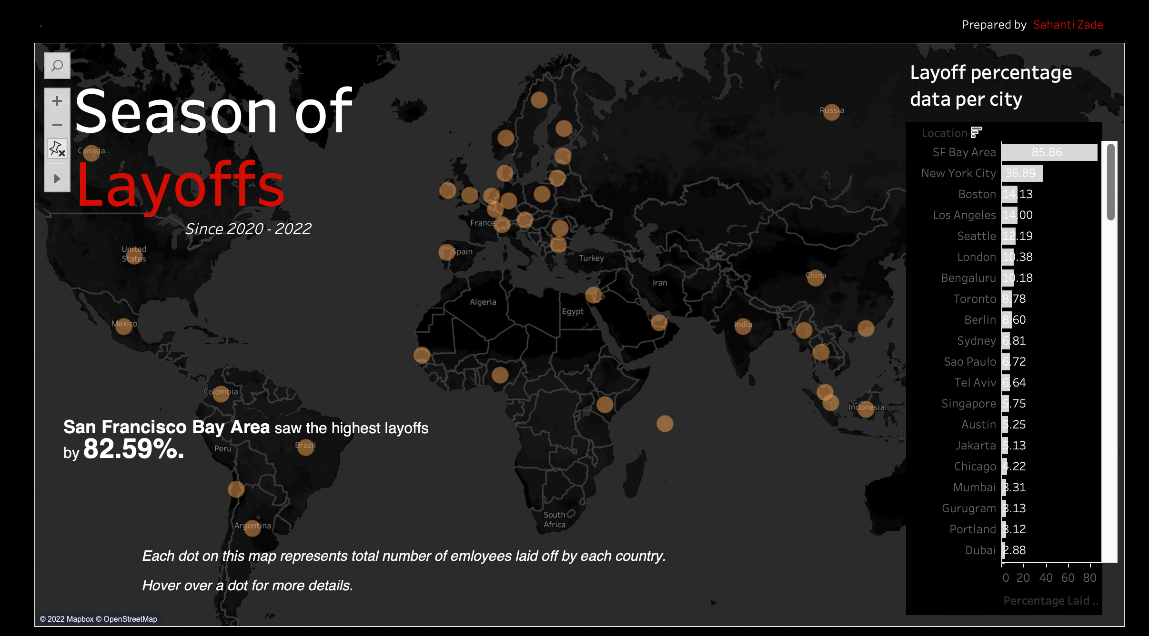

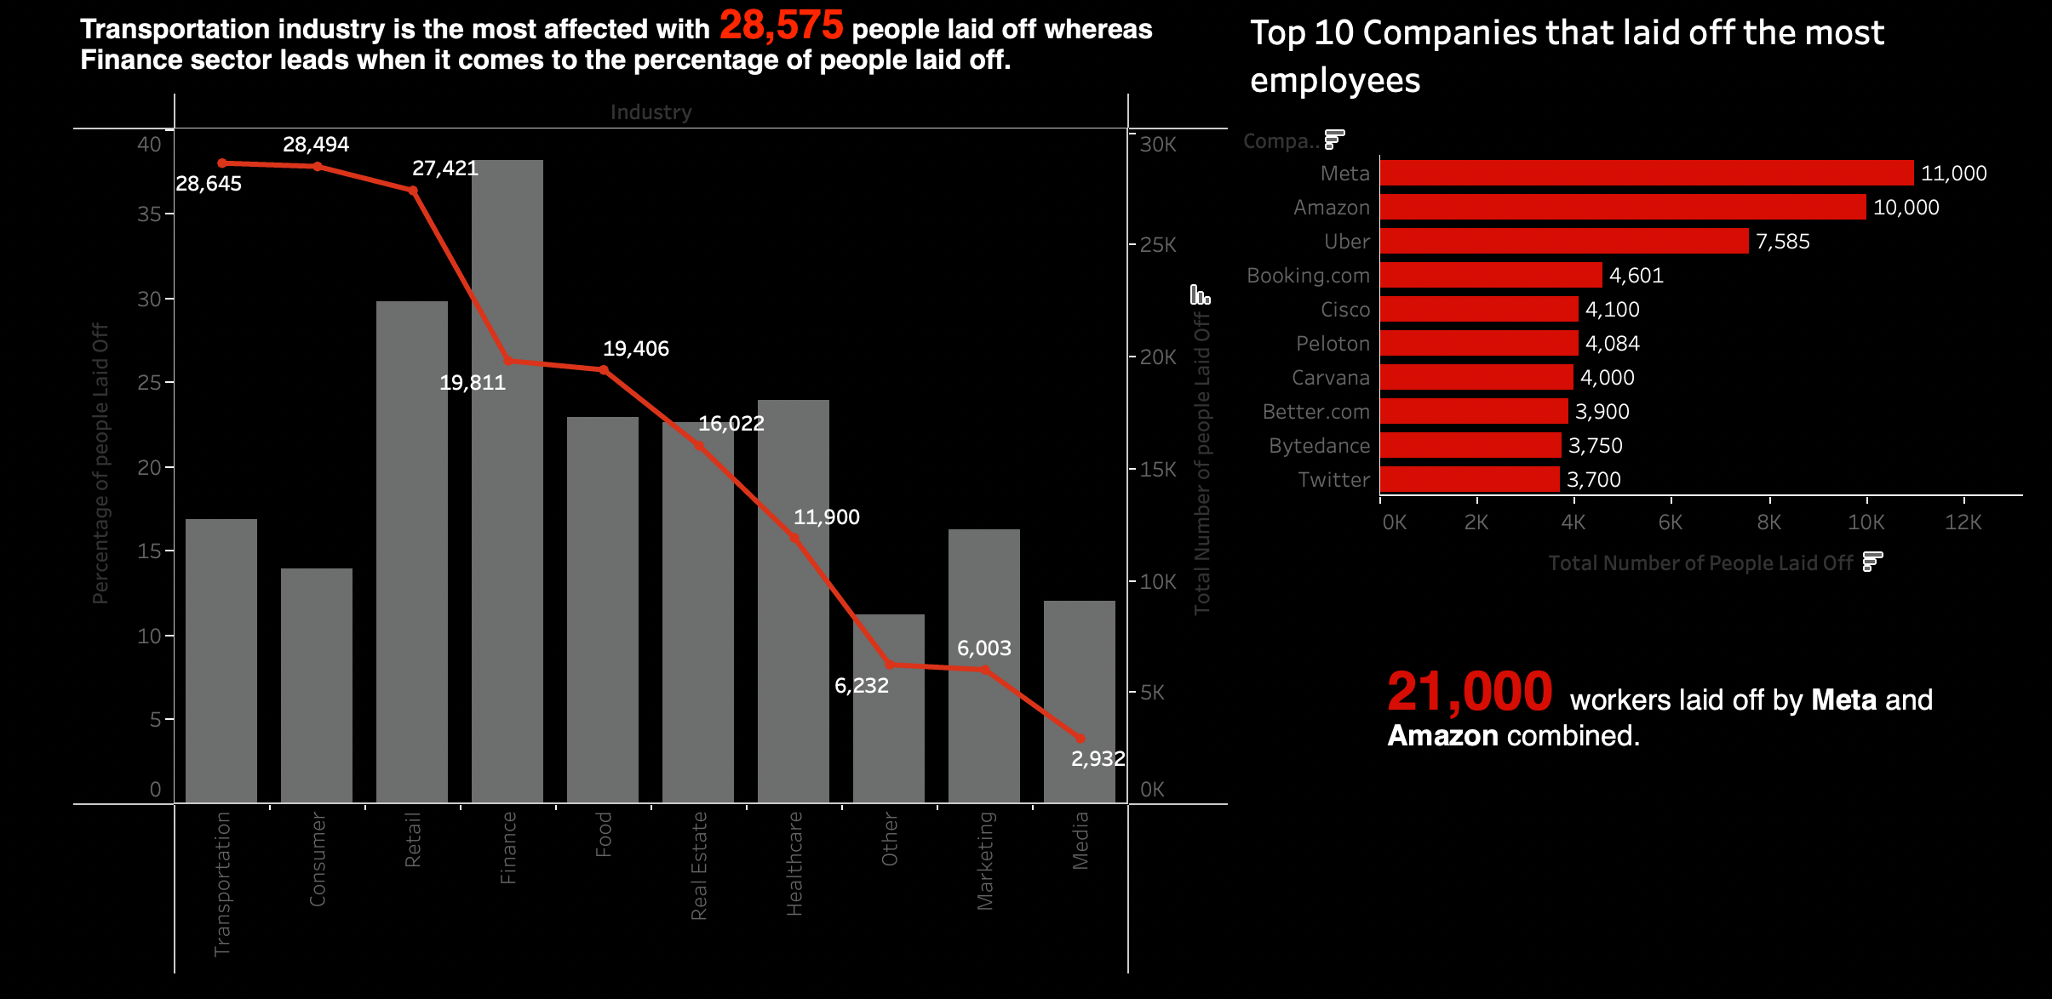

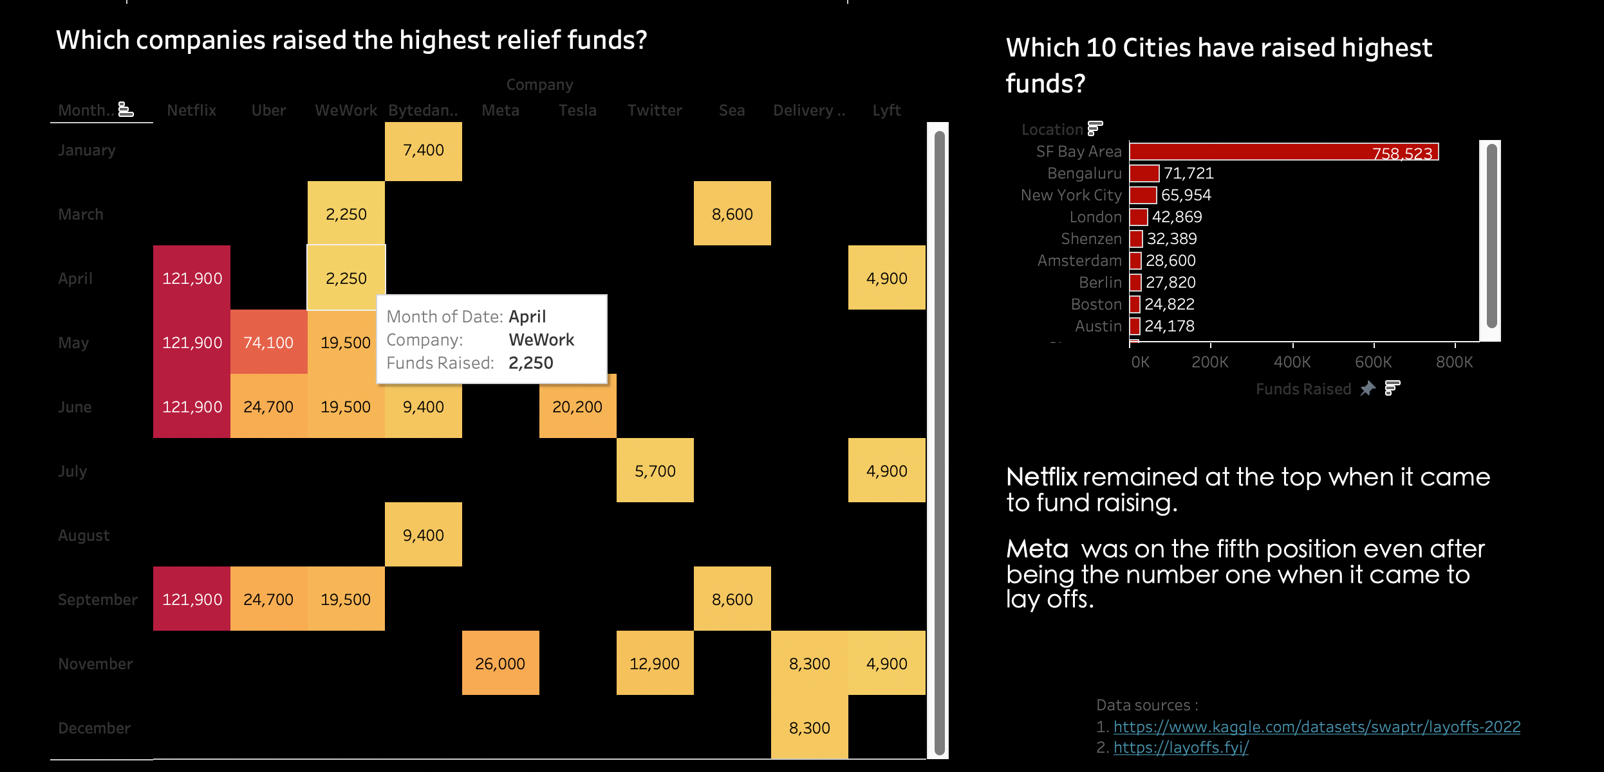

**Description of each sheet**

**Sheet 1**

* The below sheet helps us understand the number of people that got laid off per country.
* Each dot represents a country and total number of people laid off.

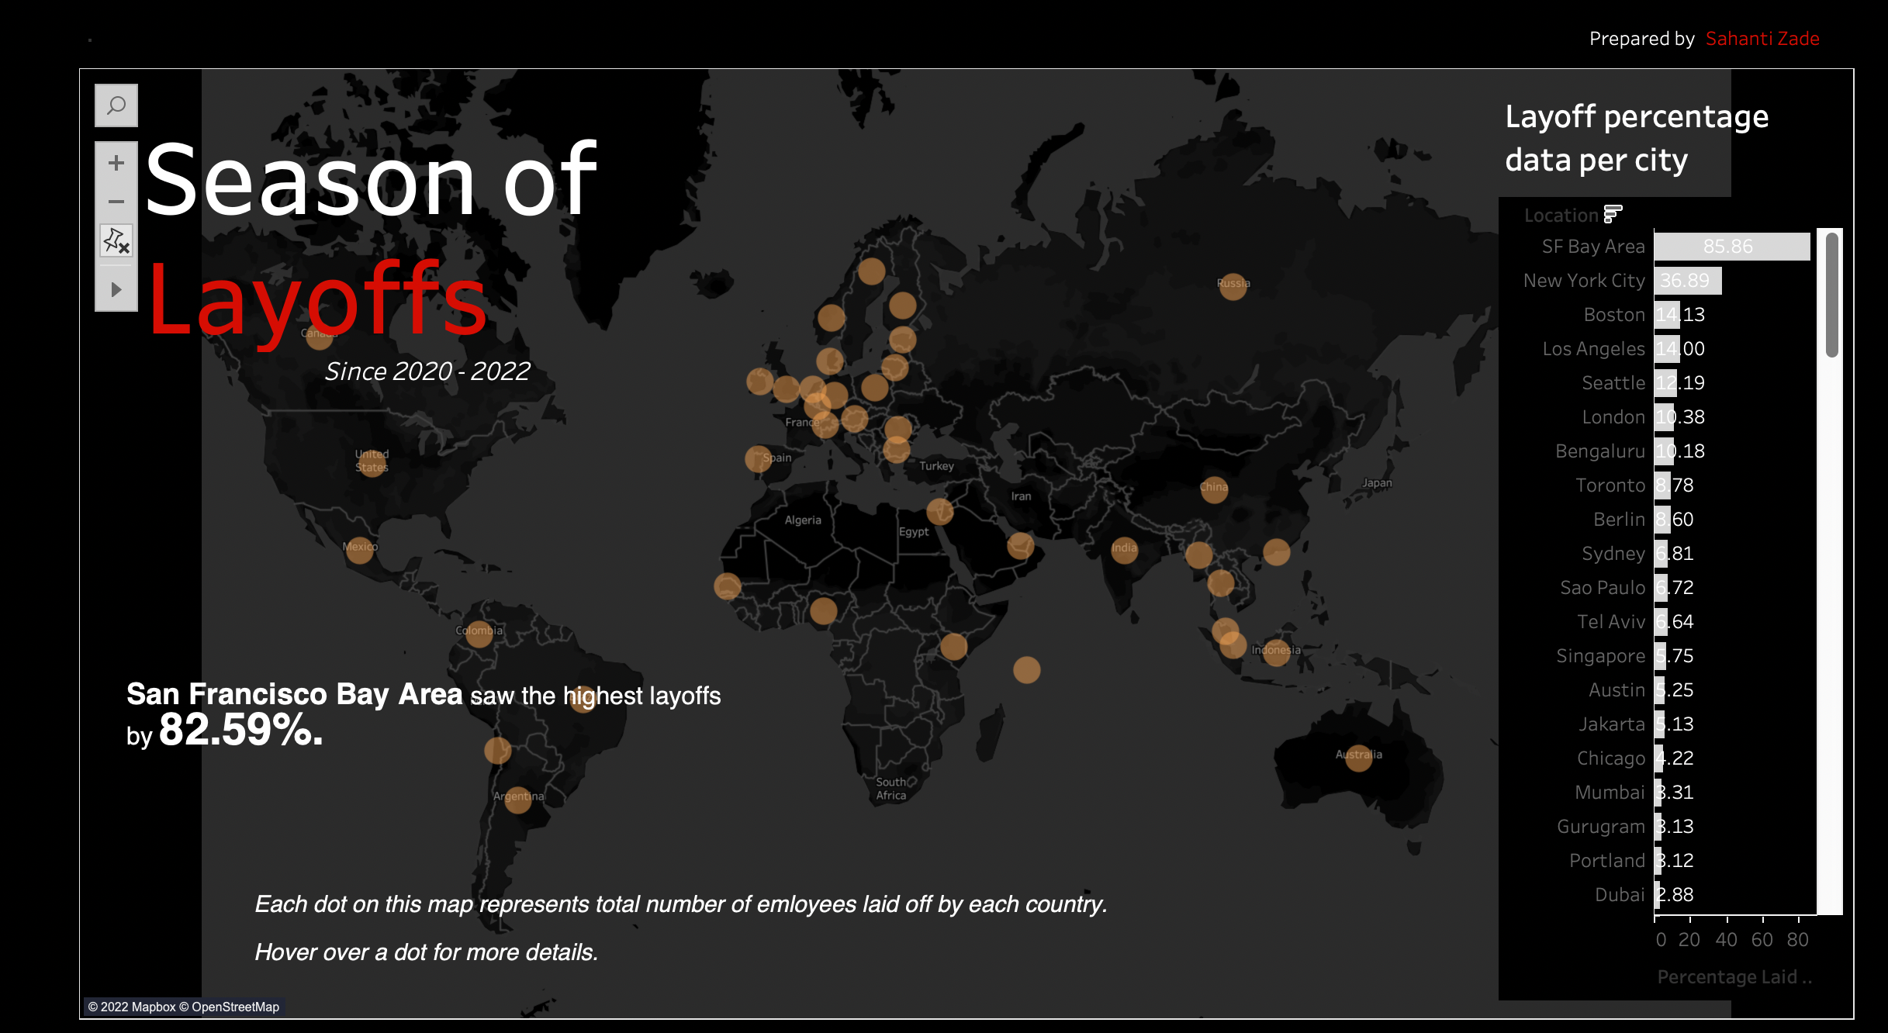

* In above sheet, we also have bar graph visualization that provide insight on the layoff percentage data per city

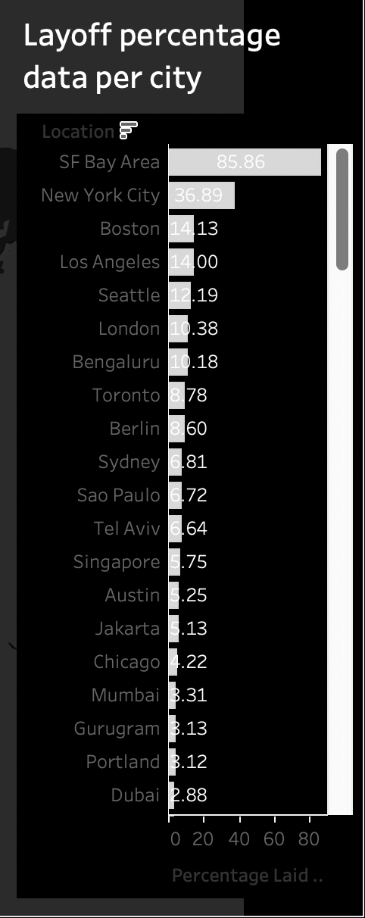

**Sheet 2**

* This sheet explains the layoffs in various industries across the globe
* The bar graph shows percentage of the people that got laid off
* The line graph shows the exact number of people laidoff in particular industry

Insights: We can infer from the graph that the Transportation industry is the most affected with 28,575. Whereas Media industry is not affected much by the layoff.

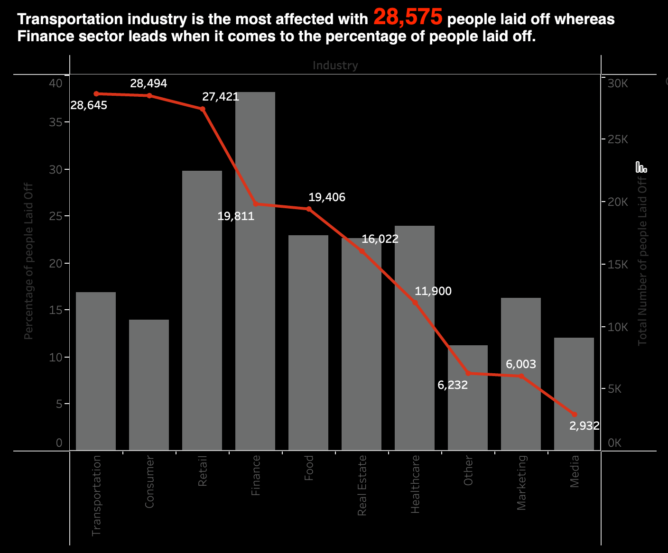

**Sheet 3**

* This sheet has a bar graph which enlists the top 10 companies who were responsible of the highest layoffs the highest number of people

Insight: Meta stands tall with the highest number of layoffs that have happened across the globe. Meta and Amazon combined have laid off 21000 employees.

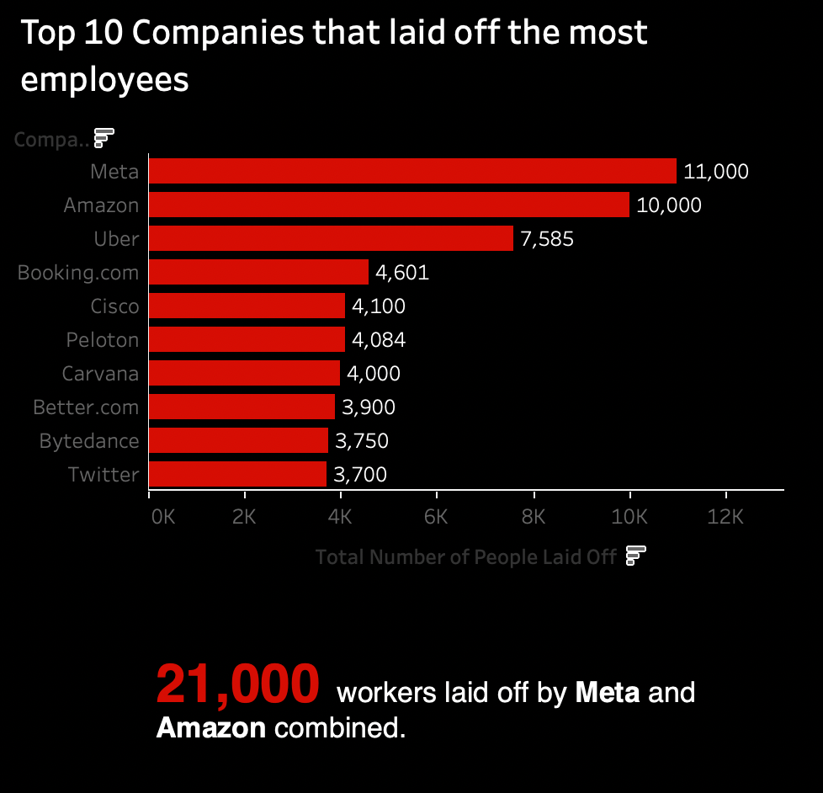

**Sheet 4**

* This sheet shows heat map which provide information on the relief funds provided by various companies

Insight: Netflix remained at the top when it came to fund raising. Meta was on the fifth position even after being the number one when it came to layoffs.

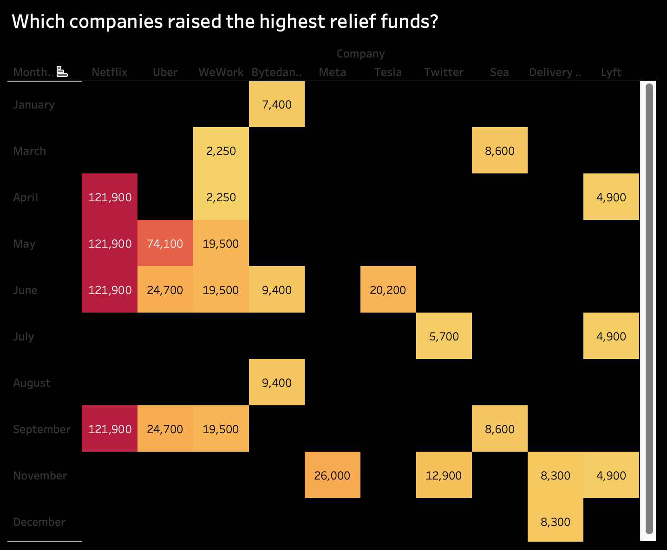

**Sheet 5**

* This sheet shows bar graph which provide information on the relief funds provided by each city

Insight: San Francisco remained at the top when it came to fund raising among the cities around the globe.

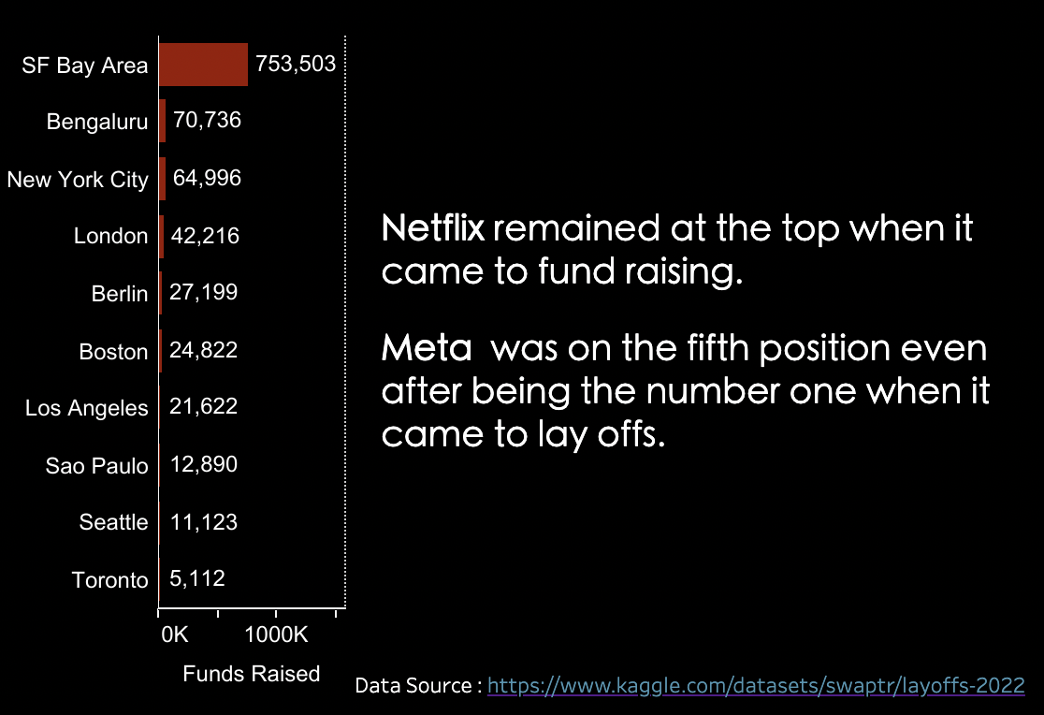

**9. Story Visualization**

I have created a story giving insight to the basic questions as below

1. Which are the top 10 countries responsible for highest layoffs?

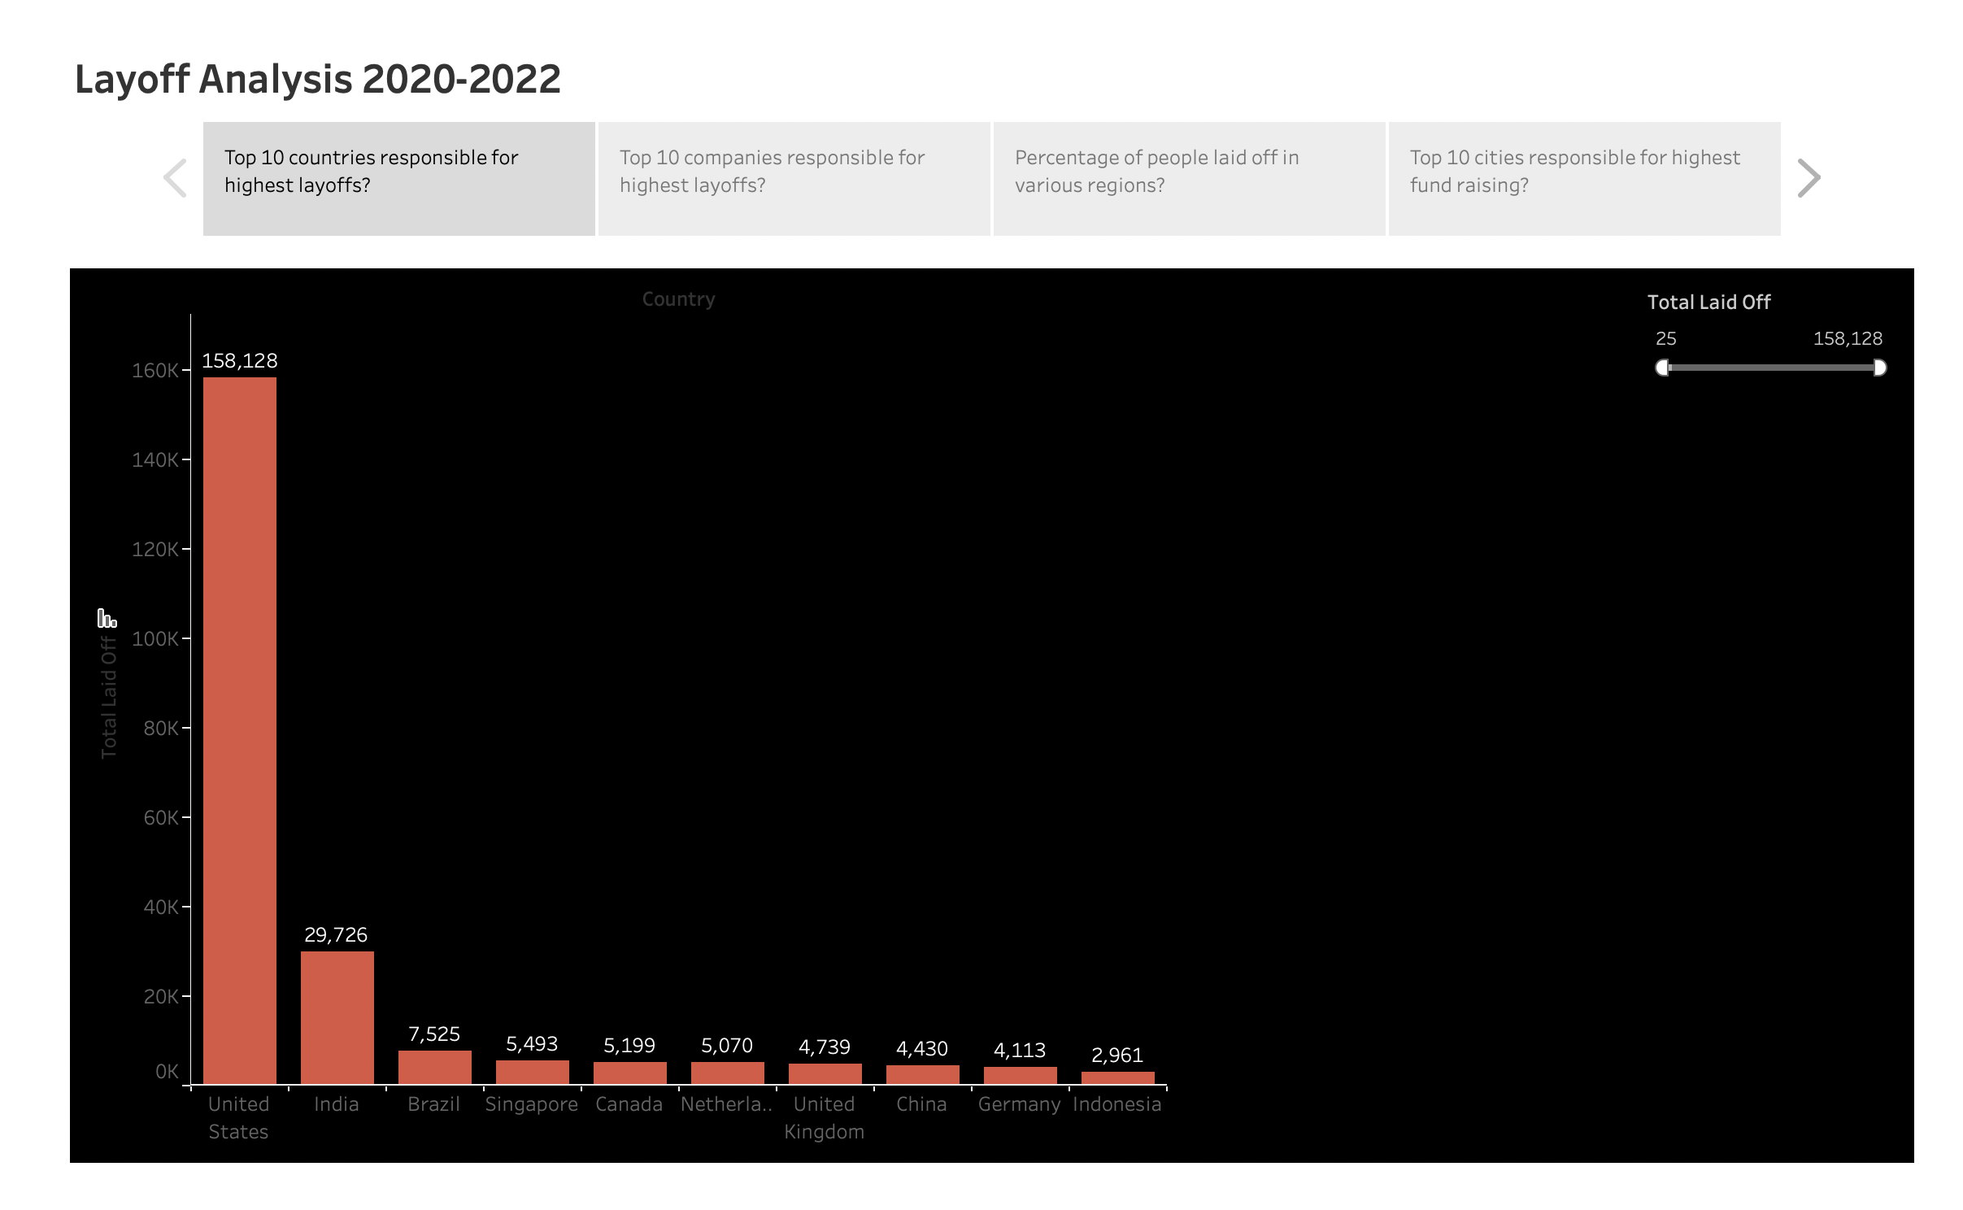

1. Which are the 10 companies responsible for highest layoffs?

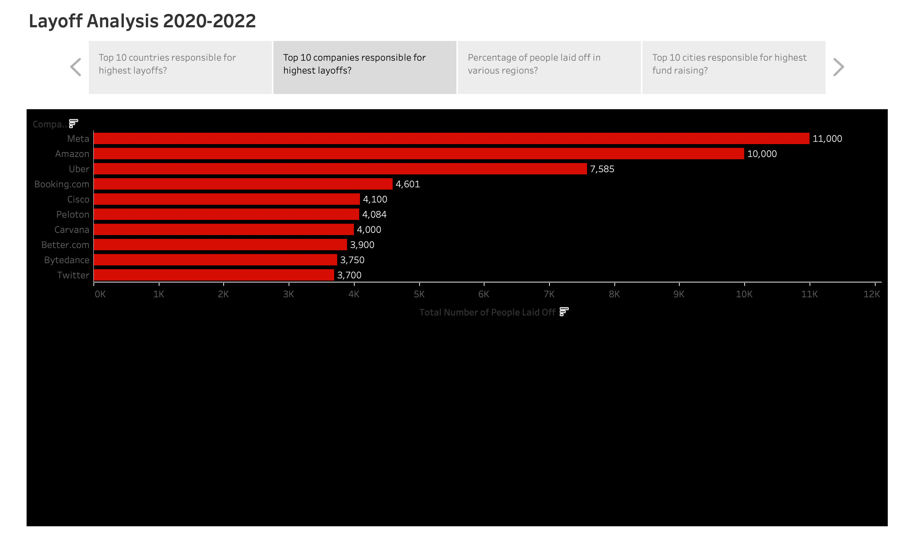

1. What is the percentage of people laid off in different regions?

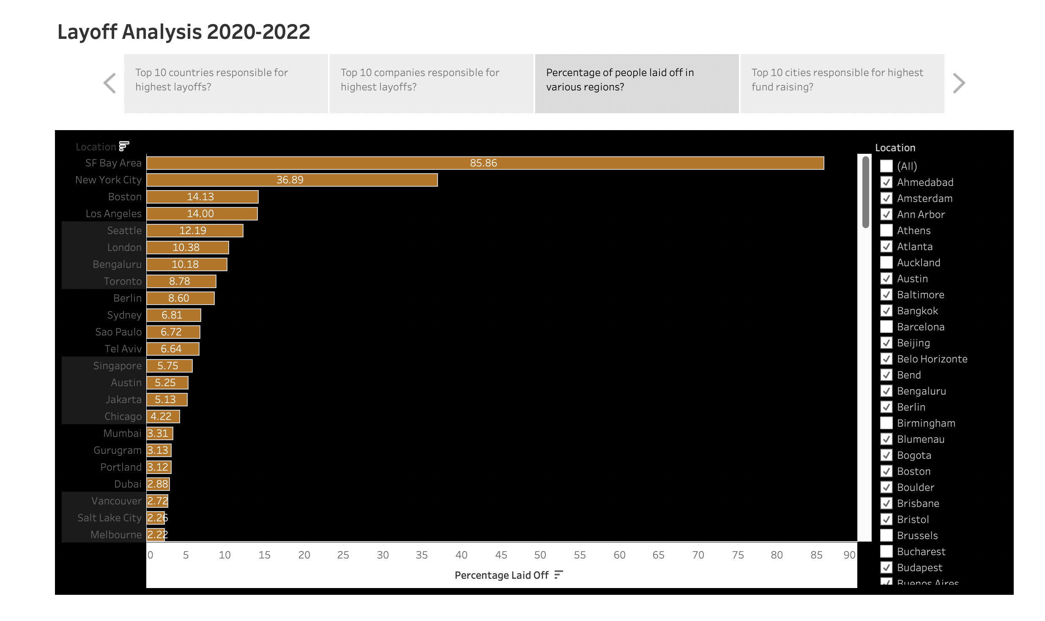

1. Which are the top 10 cities responsible for highest fund raising?

